**User Story ID**: 1

**Use Story Name**: Simplinvest landing page (For First Time Users)

**Use Story Description**: User will land on Simplinvest onboarding screen to begin their SimplInvest journey.

**Actors**: New/existing ABCD super app user.

**User Navigation**: ABCD Super App Landing Page → Invest → Simplinvest->Onboarding Splash Screen

**Functional Flow**

1. When user logs into ABCD super app and on clicking Invest dialer, the Invest landing screen will be displayed with Simplinvest banner and other options like Gold, Stock, MF and FD in tiles format
2. By clicking on Simplinvest banner at the top, Simplinvest splash screen will be displayed with contents and a "Continue" button at the bottom
3. By clicking on the continue button, Splash screen will be displayed in a carousel view and “Let's get started" button at the bottom

**Rowy:** All the Splash screens should get configured and come from Rowy

**API**: Not Applicable

**Figma link:** [Portfolio Revamp](https://protect.checkpoint.com/v2/r05/___https://www.figma.com/design/mIbZMrzUAPOKeswB9mBilJ/UI-Design?node-id=1472-13646&node-type=canvas___.YXBzMTphZGl0eWFiaXJsYWNhcGl0YWw6YzpvOjA1ZmJjZmQwYWE0OTZhOTQwMWQyMWQzMTNhZTM0YTlmOjc6OWRlMDphZWE5NGQ4ZGFkODc0NzljMDNkYjc2MTk3ZjBiNWE5Y2E2NzE4NTBiYzZlN2Y0ODMxMzk3ZTE3ZDAxNWZkZjhmOnA6RjpO)

**Acceptance Criteria:**

1. When user clicks on Simplinvest banner, the landing screen should be displayed
2. Clicking on the continue button should navigate to splash screen
3. User should be able to navigate to all available splash screens

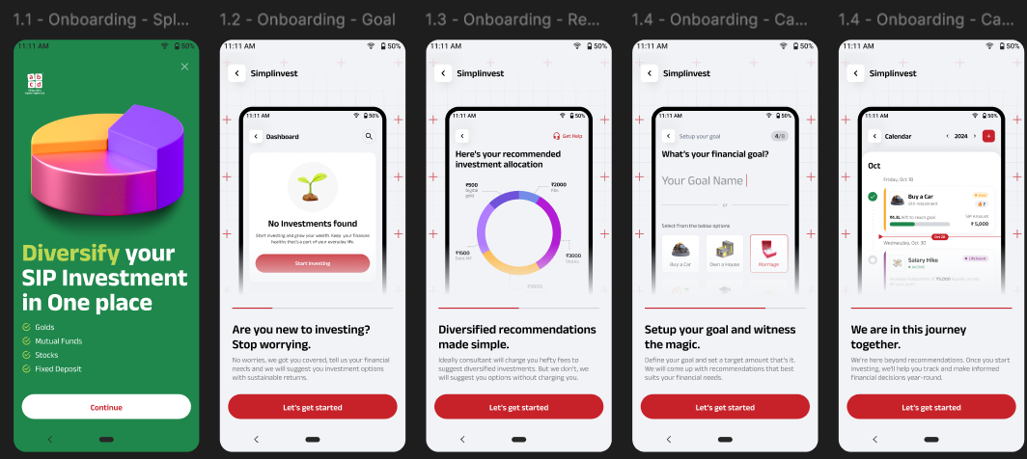

**User Story ID**: 2

**Use Story Name**: Simplinvest landing page (For Existing Users)

**Use Story Description**: User will land on Simplinvest dashboard to see their ongoing SIPs/resume their journey of SIPs is in in-progress state and Investment details cards (if applicable)

**Actors**: New/existing ABCD super app user.

**User Navigation**: ABCD Super App Landing Page → Invest → Simplinvest->Dashboard

**Functional Flow**

1. When user logs into ABCD super app and on clicking Invest dialer, the Invest landing screen will be displayed with Simplinvest banner and other options like Gold, Stock, MF and FD in tiles format
2. By clicking on Simplinvest banner at the top, user will land on dashboard and user should be able to see following details based on ongoing SIPs/SIP setup is in in-progress state
   1. Investment card at the top (If SIP is set up and 1st installment is executed)
   2. My investments -> Goals-> List of SIPs set up (If SIP is set up and 1st installment executed)
   3. “No Investments found” at top (If SIP set is in progress/ SIP set up is completed but 1st installment is not executed yet)
   4. Resume Journey -> List of SIPs set up (If SIP set is in progress/ SIP set up is completed but 1st installment is not executed yet)

**Rowy:**

1. **‘**No Investment found’ screen should come from Rowy

**Firestore**

1. Resume journey SIPs will come from firestore

**API**:

1. Returns calculation on dashboard
2. Return displayed on SIP card

**Figma link:** [Portfolio Revamp](https://protect.checkpoint.com/v2/r05/___https://www.figma.com/design/mIbZMrzUAPOKeswB9mBilJ/UI-Design?node-id=1472-13646&node-type=canvas___.YXBzMTphZGl0eWFiaXJsYWNhcGl0YWw6YzpvOjA1ZmJjZmQwYWE0OTZhOTQwMWQyMWQzMTNhZTM0YTlmOjc6OWRlMDphZWE5NGQ4ZGFkODc0NzljMDNkYjc2MTk3ZjBiNWE5Y2E2NzE4NTBiYzZlN2Y0ODMxMzk3ZTE3ZDAxNWZkZjhmOnA6RjpO)

Acceptance Criteria:

1. When user clicks on Simplinvest banner, the dashboard should be displayed
2. When user clicks on back button dashboard, user should navigate to previous screen

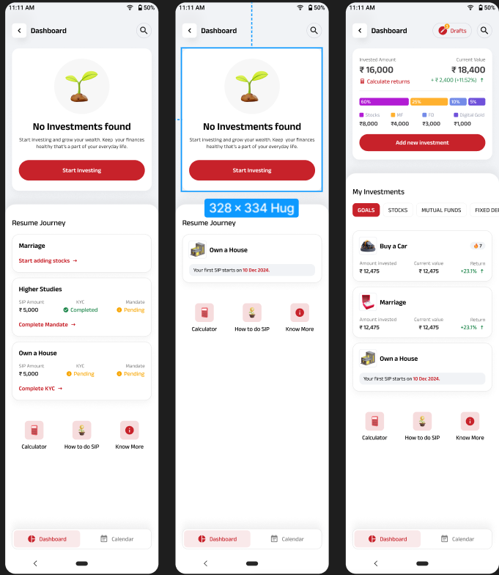

Note: Calendar will be implemented in phase 2.

**User Story ID**: 3

**Use Story Name**: Simplinvest Goal Planning

**Use Story Description**: User should be able to set up a Goal to create a SIP Basket and invest

**Actors**: New/existing ABCD super app user.

**User Navigation**: ABCD Super App Landing Page → Invest → Simplinvest

**Functional Flow**

Goal planning can be done in two scenarios, and both are given below

1. As a new user after viewing the Simplinvest splash screen and clicks on ‘Let’s get started’ button, Goal planning screen should appear
2. User can navigate to Goal set up screen from dashboard by clicking on ‘Start Investing/Add new investment’ button
3. User will land on the Goal planning screen from dashboard/completing splash screens
4. The Goal planning screen will have information about the process to be followed with “Continue” button at the bottom
5. By clicking on “Continue” button, Income details screen should be displayed with following items
   1. Back button at left with text financial information
   2. Text - “What is your annual income?” and followed by options
      1. < ₹15 Lakhs
      2. ₹15 Lakhs - ₹30 Lakhs
      3. > ₹30 Lakhs and
   3. Note section at the bottom of the screen
6. After selecting any of the income bracket given, user will navigate to Debt & Expenses screen, the screen will be displayed with following text and set of options
   1. Back button at left with text Financial information
   2. Text - “What percentage of your income goes towards paying loan or debts? For ex: Credit card, Vehicle Loan, House Loan, Personal Loan, Education loan etc... “ and following options
      1. < 20%
      2. 20% - 50%
      3. > 50%
   3. Note section at the bottom of the screen
7. After selecting any of the options on Debt & Expenses screen, user will navigate to “Set Goal”, screen will have following contents
   1. Back button at left with text Setup your goal
   2. Text – What's your financial goal?
   3. A text field to type the goal name with inline text “Your Goal Name” or
   4. An option to select the existing goal name with icon
      1. Buy a car
      2. Own a House
      3. Marriage
      4. Vacation
      5. Kids Future
      6. Savings
   5. Next button at the bottom and below the same a text “Assisted by ABC employee”
8. By clicking on Next button, user will navigate to next screen, and following contents will be available
   1. Back button at left with text Setup your goal
   2. Text – What amount would you like to invest monthly?
   3. A horizontal bar to select the amount (Min 1000 and Max 5,00,000) and selected amount will be displayed at top of the bar
   4. Increment/Decrement button to select month/year (Min and Max will be given)
   5. Alongside Increment/Decrement button a toggle switch with options year/month should be displayed
   6. Another Increment/Decrement button to be displayed to capture the Expected Return (%)
   7. Total Corpus text and amount to be displayed below the Expected Returns (The total corpus shown is calculated based on amount selected and year/month selected
   8. Below the total corpus text, following text to be displayed “Amount calculated is based on the information provided by you and is indicative”
   9. Next button at the bottom of the screen
9. By clicking on ‘Next’ button user will navigate to “Investment Preference” screen and following contents will be displayed
   1. Back button at left with text Investment Preference
   2. Text – “What is your investment objective?” and three options to select
      1. Maximise Returns
      2. Minimise Retunrs
      3. Balance the risk and returns
   3. Note section at the bottom of the screen
10. Selecting any one of the options in Investment Preference screen will navigate to next screen with following contents
    1. Back button at left with text Investment Preference
    2. Text - “What is the investment outcome you are expecting?” with following options
       1. A card with header “CONSERVATIVE RETURNS” and a bar representing returns from Low (-5.00%) to Avg (7.00%) to High (12.00%)
       2. Second card with header “BALANCED RETURNS” and a bar representing returns from Low (-12.00%) to Avg (10.00%) to High (18.00%)
       3. Third card with header “CONSERVATIVE RETURNS and a bar representing returns from Low (-19.00%) to Avg (12.00%) to High (22.00%)
    3. Note section at the bottom of the screen
11. Selecting any one of the options in Investment Preference screen will navigate to next screen with following contents
    1. Back button at left with text Investment Preference
    2. Text – “Where do you invest primarily?” and three options to select
       1. Bank FD
       2. Mutual Funds
       3. Stocks
12. By selecting any of the options in the previous screen, a splash screen with progress bar will be displayed saying “Building your investment plan. This will just take a moment”
13. The bifurcation plan should generate based on the risk profile selected and should follow below weightage

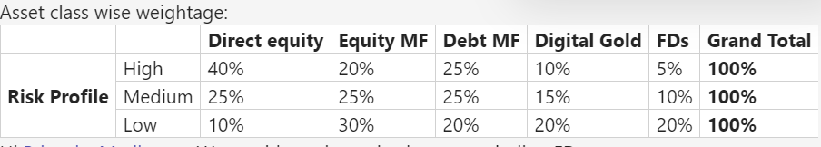

1. A new screen “SIP allocation” will be displayed with following contents
   1. A Back button at top left corner
   2. Get Help image with deep link at top right corner
   3. Text – “Here’s your recommended investment allocation”
   4. Pie Chart with allocations across Stocks, MFs, Gold and FD will be displayed
   5. Below the pie chart a text with questionnaire text “How it is calculated” is displayed and by clicking on questionnaire a pop-up with Go back button is displayed
   6. Below the same suggested “SIP Amount” with increment/decrement button will be displayed
   7. Below SIP amount, SIP Date card will be displayed with options to select on which day the SIP can be executed on every month.
   8. Next button will be displayed at bottom ~~and below the same “I'll create on my own” option will be displayed~~
   9. By clicking on next, Recommended screen will be displayed

**Rowy:**

1. Financial information, Set up your goal, Investment Preference, Splash Screens should be configured in Rowy

**API**:

1. Total corpus calculated on Goal amount screen
2. Investment allocation pop up

**Figma link:** [Portfolio Revamp](https://protect.checkpoint.com/v2/r05/___https://www.figma.com/design/mIbZMrzUAPOKeswB9mBilJ/UI-Design?node-id=1472-13646&node-type=canvas___.YXBzMTphZGl0eWFiaXJsYWNhcGl0YWw6YzpvOjA1ZmJjZmQwYWE0OTZhOTQwMWQyMWQzMTNhZTM0YTlmOjc6OWRlMDphZWE5NGQ4ZGFkODc0NzljMDNkYjc2MTk3ZjBiNWE5Y2E2NzE4NTBiYzZlN2Y0ODMxMzk3ZTE3ZDAxNWZkZjhmOnA6RjpO)

Acceptance Criteria:

1. When user clicks on ‘Let’s get started’ button, Goal planning screen should get successfully displayed
2. User should successfully be able to select the options provided with questions and navigate to new screen once the option is selected
3. User should be able to give the custom name for goal or select the default options provided
4. User should be able to select the amount in horizontal bar by scrolling across the bar
5. When user clicks on increment/decrement button, respective months/year value should get updated
6. When user clicks on year/month toggle button it should toggle based on the selection
7. When user clicks on increment/decrement button, the number should increase/decrease successfully
8. When user clicks on Next button on Set up your goal page, user should be able to navigate to Investment preference screen
9. When user clicks on Next button on pie chart bifurcation screen, it should navigate to Recommendation screen

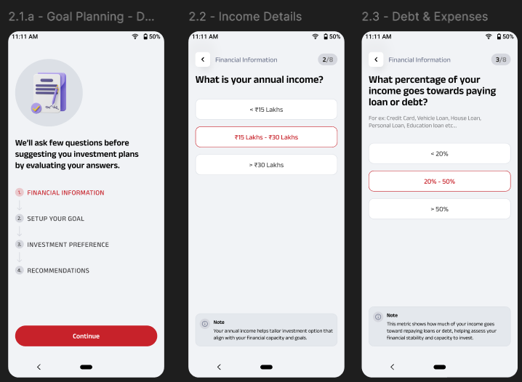 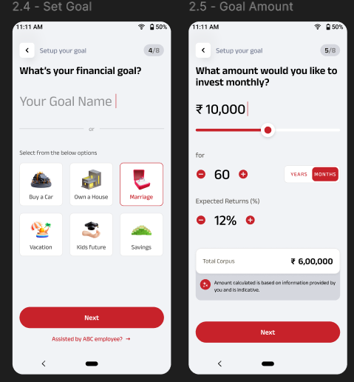

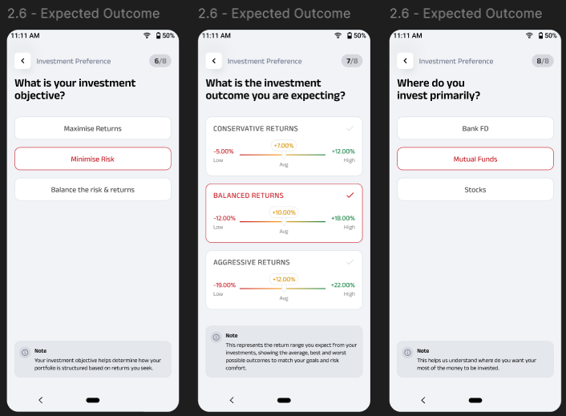 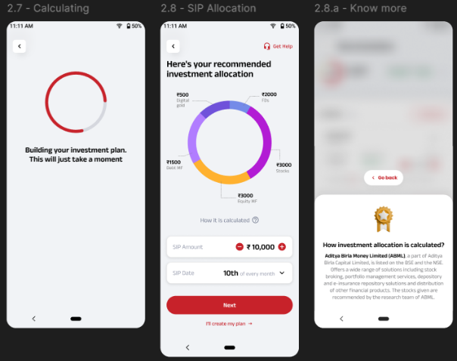

**Queries**

1. Is expected returns selected in the Goal amount screen is used for calculation anywhere
2. Min and max for Goal amount section

**User Story ID**: 4

**Use Story Name**: Recommendation flow - historical returns, progress bar and Pie chart

**Use Story Description**: User should be able to see the progress bar, check historical returns and see the pie chart

**Actors**: New/existing ABCD super app user.

**User Navigation**: ABCD Super App Landing Page → Invest → Simplinvest->Set up Goal

**Functional Flow**

After setting up the goal, the user should landon the Recommendation screen. The recommendation screen should have following items

**First Section**

1. Back button with text Recommendations at top left corner
2. Save & Exit at top right corner – By clicking on Save & Exit, current status should get saved and display on dashboard under Resume Journey if any active SIPs are not present and if any active SIPs are available then the same should get displayed in the Drafts page
3. When user kills the application, the current status should get saved and should display to user in dashboard or draft section
4. A circle progress bar at left top below back button with amount given in goal set up and total assets amount (Stock, MF, Gold or FD) added. The progress bar should get updated based on the assets added dynamically
5. Historical Returns with refresh button. The very first time, before adding the stocks/funds historical return will be calculated for suggested amount added in FD and Digital Gold section once user adds the stock or fund, historical return should get automatically updated. The historical returns will be calculated for 1 year
6. Clicking on Info icon near Historical returns should show the historical return pop up with Go back button
7. A down arrow near historical return, by expanding the same a pie chart with bifurcations of different assets should be displayed with amount of current assets added out of recommended amount
8. After adding all the assets if the asset value is different than the suggested bifurcation, then new amount should be displayed in pie chart and old amount should be stroked off

**Second Section**

1. In the second section separate tabs should be displayed for Stocks, Equity MF, Debt MF, FD and Digital Gold
2. By default, the Stock tab should be displayed and the respective ABML recommended stocks list will be displayed under the same. The contents will be displayed in the following order
   1. Heading STOCKS should be displayed with questionnaire and recommended amount in the earlier bifurcation
   2. Clicking on the questionnaire should display a pop up related to Stocks with Go back button
   3. Below the stock header, a text “* ABML Recommended” should be displayed with questionnaire. By clicking on the questionnaire ABML recommended pop up should be displayed with Go back button
   4. Below the same list of recommended stocks should be displayed in the card format
   5. If the recommended stock list is more than 3, then user should be allowed to scroll and see the other options
   6. The Stock card should contain following items
      1. Stock name
      2. Add button
      3. Stock price
      4. QVT score with questionnaire icon and by clicking on same q pop up should open with Go back button
      5. Returns (%)
      6. View stock details
   7. Explore Stocks will be displayed at the bottom
3. If user clicks on Equity Mutual Fund/Debt Mutual Fund tab the respective ABSLAMC recommended MFs list will be displayed, and the contents will be displayed in the following order
   1. Heading EQUITY MUTUAL FUNDS/DEBT MUTUAL FUNDS should be displayed with questionnaire and recommended amount in the earlier bifurcation
   2. Clicking on the questionnaire should display a pop up related to Mutual funds with Go back button
   3. Below the stock header, a text “* ABSLAMC Recommended” should be displayed with questionnaire. By clicking on the questionnaire ABML recommended pop up should be displayed with Go back button
   4. Below the same list of recommended MFs should be displayed in the card format
   5. If the recommended MFs list is more than 3, then user should be allowed to scroll and see the other options. The recommended stocks/funds should be driven from Rowy
   6. The MF card should contain following items
      1. Fund name with text View Fund Details
      2. NAV and Price
      3. Add button
      4. Returns (%)
   7. Explore Funds will be displayed at the bottom
4. If user clicks on FD tab, following details should be displayed
   1. Heading FIXED DEPOSITS should be displayed with questionnaire and recommended amount in the earlier bifurcation
   2. Clicking on the questionnaire should display a pop up related to Fixed Deposit with Go back button
   3. Below the same Fixed Deposit details card should be displayed with following contents in the card format
      1. Bank Name
      2. Delete button
      3. Interest rate (Interest rate should be configured in Rowy
      4. Amount with Increment/Decrement button (by default the amount given in the bifurcation
5. If user clicks on Digital Gold tab, following details should be displayed
   1. Heading DIGITAL GOLD should be displayed with questionnaire and recommended amount in the earlier bifurcation
   2. Clicking on the questionnaire should display a pop up related to Digital Gold with Go back button
   3. Below the same Digital Gold details card should be displayed with following contents in the card format
      1. A header - 24k 99.999 purity
      2. Delete button
      3. Price per gram
      4. Gms
      5. Amount with Increment/Decrement button (by default the amount given in the bifurcation

**Rowy:**

* ABML recommended stocks and MFS will come from ROWY via trendline API
* All the FD and Digital gold content and icon should be driven from Rowy

**Firsstore:**

1. User drops off the journey at any point the journey should get saved

**API**:

* Historical Returns comes from API (Calculated for 1 year)
* Returns displayed on the Stock or MF should come from API
* Questionnaire data for Stocks, MF, FD, Digital Gold, Historical return, QVT score, ABML recommended and ABSLAMC recommended

**Figma link:** [Portfolio Revamp](https://protect.checkpoint.com/v2/r05/___https://www.figma.com/design/mIbZMrzUAPOKeswB9mBilJ/UI-Design?node-id=1472-13646&node-type=canvas___.YXBzMTphZGl0eWFiaXJsYWNhcGl0YWw6YzpvOjA1ZmJjZmQwYWE0OTZhOTQwMWQyMWQzMTNhZTM0YTlmOjc6OWRlMDphZWE5NGQ4ZGFkODc0NzljMDNkYjc2MTk3ZjBiNWE5Y2E2NzE4NTBiYzZlN2Y0ODMxMzk3ZTE3ZDAxNWZkZjhmOnA6RjpO)

Acceptance Criteria:

1. When user clicks on Save & Exit, system should save the current status and exit
2. When user clicks on back button, user should navigate previous screen
3. When user clicks on historical returns, update value should be displayed
4. When user clicks on expand button, pie chart should be displayed and when collapse button is clicked the pie chart should get dismissed
5. When user clicks on Stocks tab, ABML recommended stocks should be displayed
6. When user clicks on Equity/Debt MF ABSLAMC recommended funds should be displayed
7. When user clicks on FD tab, bank and FD amount details with suggested amount should be displayed
8. When user clicks on Digital Gold, Digital gold card with suggested amount should be displayed
9. When user clicks on questionnaire, respective pop up should get displayed
10. When user clicks on view stock/MF details, respective details should be displayed as a pop up for stock and a fund details screen for MF

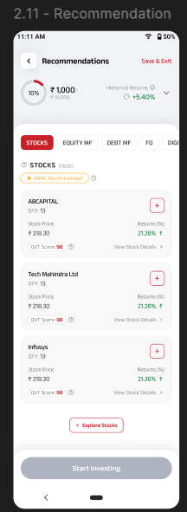 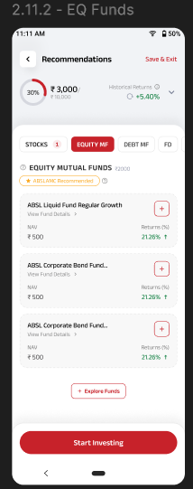 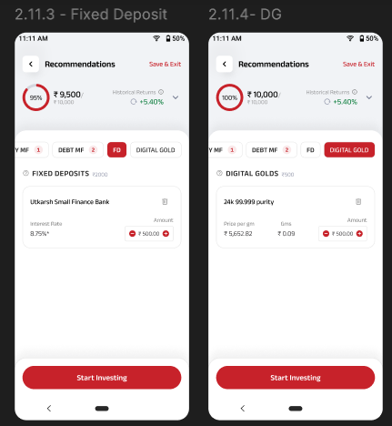

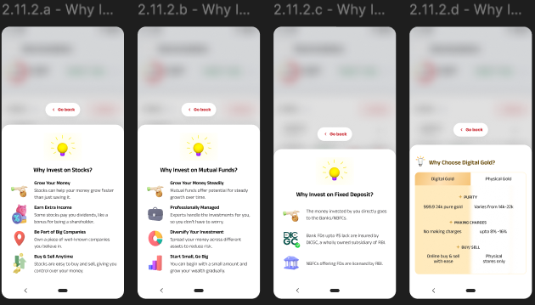

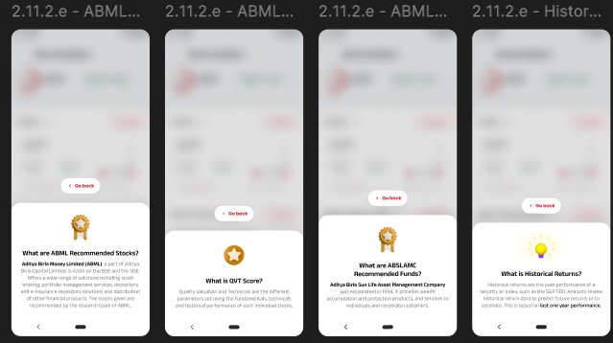

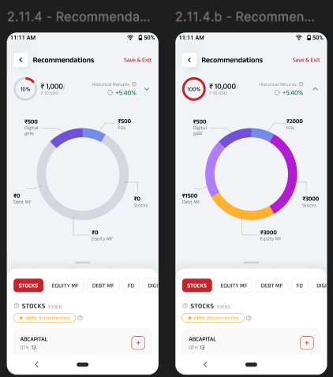

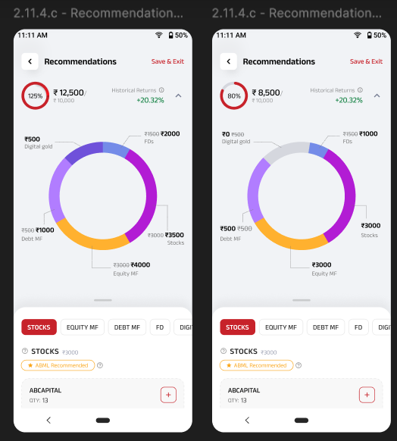

**Queries**

1. Historical return formula is asked to consider for 1 years in BRD but Stocks is calculated only for 3,6 and 12 months
2. If multiple items are selected how it is calculated. Is it based on all assets during addition of assets into basket
3. Qty needs to be removed in figma when recommended stocks are displayed (2.11)
4. On landing before adding assets. On clicking each tab for which stock or MF what we need to display historical returns?

**User Story ID**: 5

**Use Story Name**: Recommendation flow – Add Recommended Stocks, MFs and increase/Decrease Digital Gold and FD

**Use Story Description**: User should be able to add the recommended stocks, MFs, alter the amount of FD and Digital Gold

**Actors**: New/existing ABCD super app user.

**User Navigation**: ABCD Super App Landing Page → Invest → Simplinvest->Set up Goal

**Functional Flow**

**Stocks**

* After setting up the goal, the user should landon the Recommendation screen. By default, stocks tab will be selected, and user will be able to see the ABML recommended stocks in card format with add button
* By clicking on the add button on any specific stock listed, selected stock will get added to the Stock basket with amount equal to bifurcation amount suggested earlier and respective qty will be displayed. There is a chance the amount added will be nearer to the bifurcation amount based on the qty. For ex: Suggested amount is 1000, stock value is 90/stock, the qty added will be 11 and total amount displayed should be Rs. 990
* When user adds another stock in the basket, now the default amount displayed is for 1 quantity. Only for the first stock addition the bifurcation amount will be displayed
* The following details will appear in the stock card displayed
  + Stock Name
  + Delete button – By clicking on the user should be able to delete the selected stock
  + Qty
  + Stock Price
  + Returns (%)
  + Amount with increment/decrement button – By clicking on the increment/decrement button the amount will get updated/decreased based on 1 quantity of the stock
  + QVT score
  + View Stock Details- By clicking on stock details, a pop up should open with following details
    - Stock name with QVT score
    - Avg. Price
    - Change
    - Change (%)
    - Open
    - High
    - Low
    - Volume
    - 52W High
    - 52W Low
* Add more button – By clicking on the same, a new screen should be opened with ABML recommended fund and search bar to search the fund name to be added
* The Stocks tab will show a number which indicates the number of stocks added in the Stocks basket
* Start Investing button will get enabled at bottom of the screen when any one the asset is added

**MFs**

* By selecting the Equity/Debt MF tab, ABSLAMC recommended funds will be displayed in the card format. By clicking on the add button available on any specific fund will add that selected fund to the MF basket with suggested amount as default in the amount section
* When user adds another Fund in the basket, now the default amount displayed is Rs.500 or the minimum value of the fund. Only for the first fund addition will the bifurcation amount be displayed.
* The Selected fund will get displayed with following items
  + Fund Name
  + Delete button – To delete the selected fund from MF basket
  + View Fund Details – Clicking on the View Fund Details will land on Fund Details Screen
  + NAV with Amount
  + Returns (%)
  + Amount with increment/decrement button – By clicking on the increment/decrement button the amount will get updated/decreased by Rs.500 for the fund or by the minimum value of the fund
* Explore Funds button – By clicking on the same, a new screen should be opened with ABSLMAC recommended funds and search bar to search the fund name to be added
* The Equity/Debt MFs tab will show a number which indicates the number of funds added in the Stocks basket
* Start Investing button will get enabled at bottom of the screen when any one the asset is added

**FD**

* By selecting the FD tab, user will see a Header Fixed Deposits with questionnaire and amount suggested in the bifurcation
* Below the same Fixed Deposit details card should be displayed with following contents in the card format
  + Bank Name
  + Delete button – To delete the added FD card from the Fixed deposit basket
  + Interest rate
  + Amount with Increment/Decrement button (by default the amount given in the bifurcation will be displayed)
  + When user clicks on increment/decrement button the price will be added/decreased to the FD amount by Rs. 100
* Start Investing button will get enabled at bottom of the screen when any one the asset is added

**Digital Gold**

* If user clicks on Digital Gold tab, following details should be displayed
  + Heading DIGITAL GOLD should be displayed with questionnaire and recommended amount in the earlier bifurcation
  + Clicking on the questionnaire should display a pop up related to Digital Gold with Go back button
  + Below the same Digital Gold details card should be displayed with following contents in the card format
    - A header - 24k 99.999 purity
    - Delete button – To delete the added digital gold from the Digital Gold Basket
    - Price per gram
    - Gms
    - Amount with Increment/Decrement button (by default the amount given in the bifurcation)
    - When user clicks on the increment/decrement button the amount should get added/decreased by Rs. 100
* Start Investing button will get enabled at bottom of the screen when any one the asset is added

**Rowy:**

* ABML recommended stocks and MFS will come f**rom ROWY via trendline API**
* **All contents and icons to be configred in Rowy**

**API**:

1. Questionnaire data for pop ups
2. Historical returns
3. Return displayed on cards

**Figma link:** [Portfolio Revamp](https://protect.checkpoint.com/v2/r05/___https://www.figma.com/design/mIbZMrzUAPOKeswB9mBilJ/UI-Design?node-id=1472-13646&node-type=canvas___.YXBzMTphZGl0eWFiaXJsYWNhcGl0YWw6YzpvOjA1ZmJjZmQwYWE0OTZhOTQwMWQyMWQzMTNhZTM0YTlmOjc6OWRlMDphZWE5NGQ4ZGFkODc0NzljMDNkYjc2MTk3ZjBiNWE5Y2E2NzE4NTBiYzZlN2Y0ODMxMzk3ZTE3ZDAxNWZkZjhmOnA6RjpO)

**FireStore:**

Save and Exit should save the current status in firestore

Acceptance Criteria:

1. When user clicks on Add button in the stock details card, the stock should get added to stock basket successfully
2. When user increases/decreases the amount, it should get increased/decreased
3. When user clicks on delete button the stock should get deleted from the Stock basket
4. When user clicks on Add button in the fund details card, the stock should get added to MF basket successfully
5. When user increases/decreases the amount, it should get increased/decreased
6. When user clicks on delete button on fund details card, the fund should get deleted from the Stock basket
7. When user clicks on delete from FD card, the FD details should get deleted from FD basket
8. When user clicks on delete from Digital Gold details card, the Digital Gold details should get deleted from FD basket

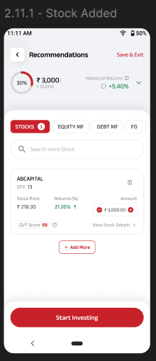 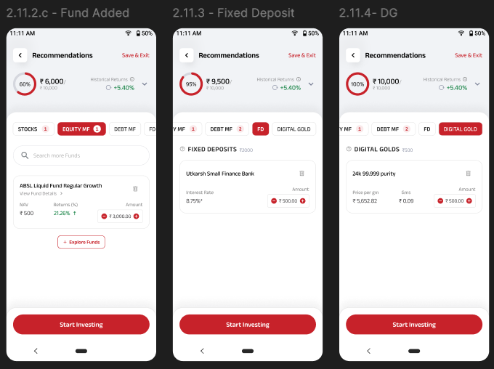

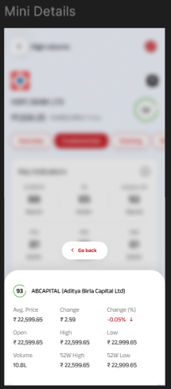

**Queries**

1. Add more option can be used instead of Explore funds in Equity/Debt MF add fund page similar to sock page.

**User Story ID**: 6

**Use Story Name**: Recommendation flow – Add stocks and funds by clicking on Add more/Explore funds

**Use Story Description**: User should be able to add the stocks and funds other than recommended flow by clicking on Add more/Explore funds

**Actors**: New/existing ABCD super app user.

**User Navigation**: ABCD Super App Landing Page → Invest → Simplinvest->Set up Goal

**Functional Flow**

**Stocks**

* After setting up the goal, the user should landon the Recommendation screen. By default, stocks tab will be selected, and user will be able to see the ABML recommended stocks in card format and Explore Stocks button
* By clicking on the Explore stocks, user will navigate to ‘Select Stock’ screen with search bar and ABML Recommended stock list in card format
* User can add ABML recommended stock from the list or type any stock name in the search bar and select the requested stock from the list displayed because of Serach operation
* By clicking on Add (+) button, user can add the stock and increase/decrease the invested amount by clicking on increment/decrement button
* The stock will get added with suggested amount if it is the first stock under the stock basket or the amount added will be of 1qty of the stock
* Once a stock is added, at bottom of the screen a text “Your invested amount” and total amount of stocks added will be displayed along with Add stock button.
* In Add stock button, total number of stocks selected will be displayed
* By clicking on the Add stock, the stocks get added to the Stock basket and Stock added screen will be displayed

**MFs**

* By clicking on, Equity MF/Debt MF tab user will be able to see the ABSLAMC recommended funds in card format and Explore funds button
* By clicking on the Explore funds, user will navigate to ‘Select Funds’ screen with search bar and ABSLAMC Recommended funds list in card format
* User can add ABSLAMC recommended funds from the list or type any fund name in the search bar and select the requested fund from the list displayed because of Serach operation
* By clicking on Add (+) button, user can add the fund and increase/decrease the invested amount by clicking on increment/decrement button
* The fund will get added with suggested amount if it is the first fund under the MF basket or the amount added will be Rs.500 or minimum value of the fund
* Once a fund is added, at bottom of the screen a text “Your invested amount” and total amount of funds added will be displayed along with Add Funds button.
* In Add Funds button, total number of funds selected will be displayed
* By clicking on the Add funds, the funds get added to the MF basket and Fund added screen will be displayed

**Rowy:**

* ABML recommended stocks and MFS will be listed in ROWY

**API**:

1. Google API is used to fetch the details of recommended stocks/funds details from Trendline API
2. For normal stocks/funds Trendline API is used to get the details directly

**Figma link:** [Portfolio Revamp](https://protect.checkpoint.com/v2/r05/___https://www.figma.com/design/mIbZMrzUAPOKeswB9mBilJ/UI-Design?node-id=1472-13646&node-type=canvas___.YXBzMTphZGl0eWFiaXJsYWNhcGl0YWw6YzpvOjA1ZmJjZmQwYWE0OTZhOTQwMWQyMWQzMTNhZTM0YTlmOjc6OWRlMDphZWE5NGQ4ZGFkODc0NzljMDNkYjc2MTk3ZjBiNWE5Y2E2NzE4NTBiYzZlN2Y0ODMxMzk3ZTE3ZDAxNWZkZjhmOnA6RjpO)

Acceptance Criteria:

1. When user clicks on Explore stocks/Add more from Stock tab, new screen with of stocks should be displayed
2. When user clicks on Explore funds from Equity/Debt MF tab, new screen with list of funds should be displayed
3. When user type a text on search and do a search, respective results should be displayed
4. When user selects stock/MF and does a add from bottom of the screen, the selected Stock/MF should get displayed under respective tabs

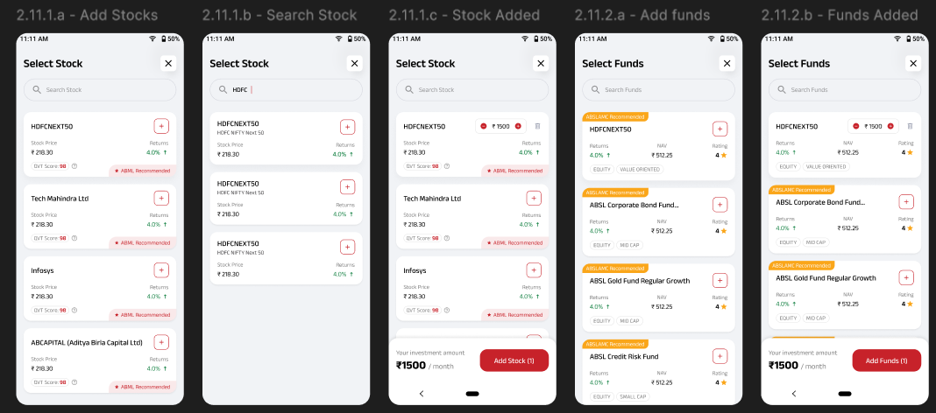

**User Story ID**: 7

**Use Story Name**: KYC and Payment

**Use Story Description**: User should be able to complete the order summary after adding the assets

**Actors**: New/existing ABCD super app user.

**User Navigation**: ABCD Super App Landing Page → Invest → Simplinvest->Set up Goal-> Complete Recommendation->Order Summary

**Functional Flow**

Once the addition of assets is completed and user clicks on ‘Start Investing’ button displayed at the bottom of recommendation screen, user will navigate to order summary page. The order summary page should have following contents

* A back button at top left corner with text Order Summary and Goal name
* A Question icon at the right top corner, by clicking on the same should take the user to help section
* A progress section with header Set Up SIP in 15 mins and a text ‘Documents Required’
* The progress bar will be dynamically updated once user completed KYC, E-mandate and Bank Account set up
  + The progress bar logic should give weightage to 25% each for Stocks, Funds, FD and Digigold
  + Stocks, Funds, FD and Digigold has 2 setups (KYC and E-mandate) so the weightage will be 12.5 for each action but on completion it should be rounded off whole number
  + FD will have only one action, so on completion of same it will be considered as 25%
  + By clicking on Documents required, a pop up will be opened with separate tabs for Stock, MF, Digital Gold and FD. By default, Stock will be selected and following documents will be required
    - PAN Card with brief description
    - Aadhar card with brief description
    - Live Photo with brief description
* Below the Set up SIP card, Stocks card should be displayed
  + 5 mins Setup tag should be displayed at left top of the card
  + Stocks with Amount of assets selected
  + Create Demat account link – By clicking on the link should follow the process of creating a Demat account like in the existing flow
* Below the Stocks card, Mutual fund card should be displayed
  + 5 mins Setup tag should be displayed at left top of the card
  + Mutual fund with Amount of assets selected
  + A link to ‘Complete Your KYC’ will be displayed – By clicking on the link should follow the process of completing the KYC like existing flow
* Below the Mutual fund card, Digital Gold card should be displayed
  + 5 mins Setup tag should be displayed at left top of the card
  + Digital Gold text with invested amount should be displayed
  + A link to Complete the 'Setup Account' will be displayed – By clicking on the link should follow the process of completing the KYC like existing flow
* Below the Digital Gold card, Deposit card should be displayed
  + 5 mins Setup tag should be displayed at left top of the card
  + Deposit text with invested amount should be displayed
  + A link to Complete the 'Setup Account' will be displayed – By clicking on the link should follow the process of completing the KYC like existing flow
* At bottom total SIP basket amount/month will be displayed with link view plan details, proceed button will be in disabled state and Save button to save the progress
* If user clicks on Save/kills the app then the status should get saved and user should be able to access from dashboard/drafts screen
* Once the KYC/Setup is completed for Stocks/Mutual Fund/Digital Gold, ‘5 mins Setup’ card header will change into KYC completed and ask for Setup E-mandate to respective cards
* For FD, once the Set-up account is completed, the header will change into Setup is completed
* When user clicks on E-mandate, will navigate to a pop up requesting for bank account details
  + Account type – By default it will be prefilled as ‘Savings’ and user will not allow to edit
  + Account number – User should be able to edit/enter the number
  + Bank Name – User should be able to input the bank name
  + Customer Name – User will be able to input the customer's name
  + Mobile no - User will be able to enter the customer phone number
  + Mandate amount – Total amount allocated in SIP basket and will be prefilled and in locked state
  + Mandate expiry – Mandate expiry date and will be in locked state
  + Create Mandate button at bottom, by clicking on the same E-mandate set up success message should be displayed
* Once mandate is completed, Success message screen should be displayed with SIP amount, SIP date on every month, bifurcation of assets in bar chart, added stock, MF, FD and Gold details in card format
* Back to dashboard button at bottom

Firestore:

1. Saved status of KYC, Mandate should get saved in firestore

Digio – KYC, E-mandate, payments and document upload part will be handled by digio

**Figma link:** [Portfolio Revamp](https://protect.checkpoint.com/v2/r05/___https://www.figma.com/design/mIbZMrzUAPOKeswB9mBilJ/UI-Design?node-id=1472-13646&node-type=canvas___.YXBzMTphZGl0eWFiaXJsYWNhcGl0YWw6YzpvOjA1ZmJjZmQwYWE0OTZhOTQwMWQyMWQzMTNhZTM0YTlmOjc6OWRlMDphZWE5NGQ4ZGFkODc0NzljMDNkYjc2MTk3ZjBiNWE5Y2E2NzE4NTBiYzZlN2Y0ODMxMzk3ZTE3ZDAxNWZkZjhmOnA6RjpO)

Acceptance criteria:

1. When user clicks on Complete Your KYC, user will be redirect to complete KYC screen
2. When user clicks on Setup E-mandate, user will be redirect to E-madate popup
3. When user clicks on Setup Account, user will be redirect to complete Setup screen
4. When user clicks on Proceed button after completing the setup, Sip Investment successful message should be displayed

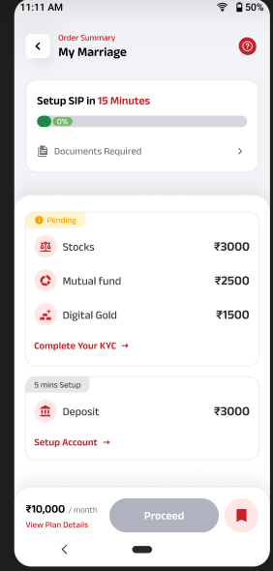 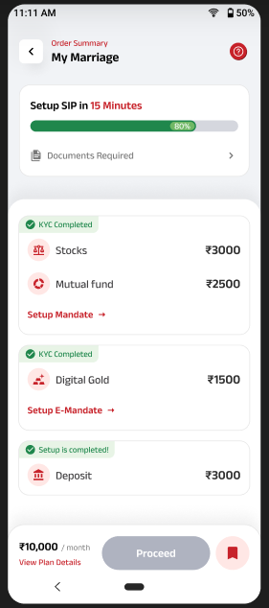 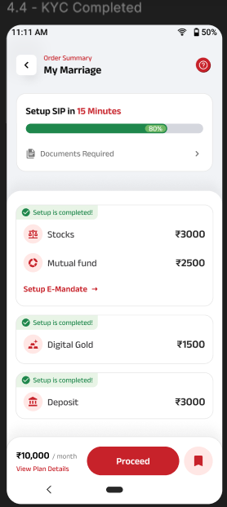

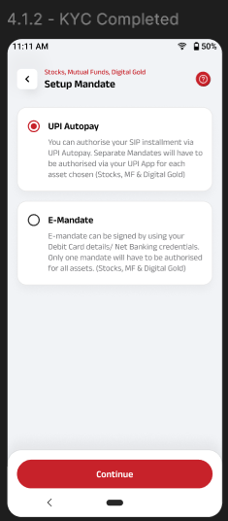 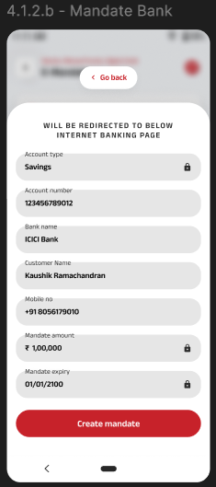 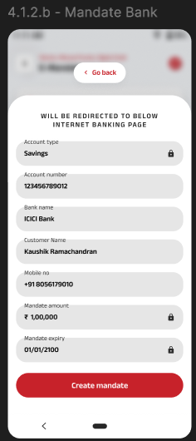

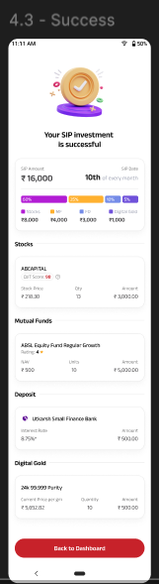

**Queries**

1. E-mandate is targeted for Phase 1 can we remove UPI mandate screens in figma
2. Why set up E-mandate is given in two cards one for Stock and MF and second one for Digital Gold
3. What is the minutes bifurcation on choosing less number of assets?

**User Story ID**: 8

**User Story Name**: Dashboard (Without Portfolio, Pre-SIP State, Default and Draft)

**User Story Description**: User should be able to navigate to Dashboard

**Actors**: New/existing ABCD super app user.

**User Navigation**: ABCD Super App Landing Page → Invest → Simplinvest->Dashboard

**Functional Flow**

There are three different types of dashboards displayed to the user in different scenarios. The scenarios are

**Without Portfolio**

When user doesn't have any active/ongoing SIPs, or the SIP creation is in progress state. The dashboard will have following contents

1. “No Investment found” card at top with some text and “Start Investing” button
2. When user clicks on “Start Investing button”, will navigate to Goal Set up screen
3. Below Start Investing button, Resume Journey cards will be displayed
4. The Resume journey cards will be displayed based on the current progress of SIP set up with Goal Name, SIP Amount, KYC, Mandate status with link to complete the KYC, Mandate and account setup

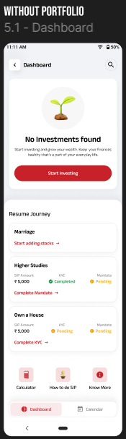

1. Below the cards ‘Calculator’, ‘How to do SIP’ and ‘Know more’ buttons should be displayed

**Pre-Sip State**

1. When user doesn't have any active/ongoing SIPs, but the SIP set up is completed and waiting for 1st installment to be executed
2. “No Investment found” card at top with some text and “Start Investing” button
3. When user clicks on “Start Investing button”, will navigate to Goal Set up screen
4. Below Start Investing button, Resume Journey SIP cards will be displayed for SIPs for which the setup is completed
5. The set up completed SIP card will have following details
   1. Goal Name
   2. A text message “Your First SIP starts on 10 Dec 2024” displaying the first SIP execution date
   3. By clicking on the any one of the available SIP cards will redirect to those specific details page
6. Below the cards ‘Calculator’, ‘How to do SIP’ and ‘Know more’ buttons should be displayed

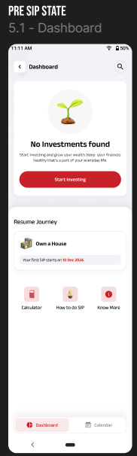

**Default**

1. When user any active/ongoing SIPs then default dashboard with Invested details, Invested SIPs and setup completed SIPs will be displayed.
2. The page is divided into two halves Investment Amount at top and My Invest at second level
3. A back button at top left with text as Dashboard
4. Drafts icon at the top right
5. A search bar at top right end
6. The top card will have following details
   1. Invested Amount – Total amount invested till across multiple SIP baskets
   2. Current value – Current value of invested amount in Rs as well as percentage
   3. Bifurcation of assets invested is displayed as bar chart with name of the asset, percentage and amount
   4. Add new investment button - will navigate to Goal Set up screen

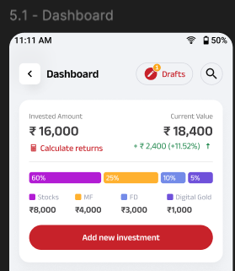

1. Second section will be My Investments section, this section will contain the individual SIP basket where user has invested and set up completed SIP basket
2. The active SIP basket will have following details
   1. Goal Name
   2. Amount Invested
   3. Current value
   4. Return
   5. Fire icon with number indicating the total number of payments done
3. By clicking on the current active SIP basket will navigate to the respective SIP details page
4. The setup completed SIP card will have following details
   1. Goal Name
   2. A text message “Your First SIP starts on 10 Dec 2024” displaying the first SIP execution date
   3. By clicking on the any one of the available SIP cards will redirect to those specific details page
5. Below the cards ‘Calculator’, ‘How to do SIP’ and ‘Know more’ buttons should be displayed

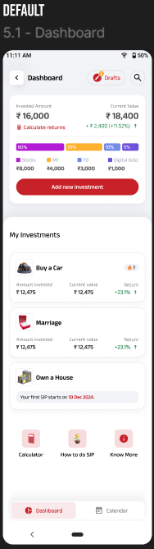

**Rowy**:

1. No investments found screen should be configured in Rowy

**Firestore:**

1. The resumed journey items should come from firestore

**API**

1. Current value calculations on dashboard
2. Payment streaks of a particular SIP basket
3. Current value calculation displayed on Individual SIP cards
4. Return calculation displayed on Individual SIP cards

**Acceptance Criteria:**

1. When user clicks on back button previous page should be displayed
2. When user clicks on Start Investing/Add new Investment, Goal set up screen should be displayed
3. Clicking on Start adding stocks from a SIP card displayed under resume journey should navigate to Recommend page
4. When user clicks on Complete KYC/Set up Mandate should redirect to digio SDK
5. When user clicks on any SIP card for which setup is completed or ongoing SIP then that particular SIP details page should be opened
6. When user clicks on draft button, user should navigate to Drafts screen

**Queries**

1. Can we remove calendar option in Figma since calendar is targeted for phase 2

**User Story ID**: 9

**Use Story Name**: View Individual SIP Baskets

**Use Story Description**: User should be able to View Individual SIP Basket details

**Actors**: New/existing ABCD super app user.

**User Navigation**: ABCD Super App Landing Page → Invest → Simplinvest->Dashboard

**Functional Flow**

In dashboard when clicks on any one the SIP under My Investments, user will navigate to respective SIP details page and following contents will be displayed. The page is divided into two sections Investment Details at the top and second section consists of Investment and SIP Details tab

**Investment Details Section**

1. Goal name with back button at top left
2. FAQ section at top right
3. Invested Amount – Total amount invested till across multiple SIP baskets
4. Current value – Current value of invested amount in Rs as well as percentage
5. Bifurcation of assets invested is displayed as bar chart with name of the asset, percentage and amount
6. Progress bar showing Saved amount and Goal amount

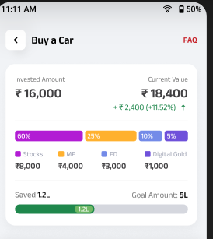

**Second Section (Investment and SIP Details)**

**Investments**

There will be two tabs Investments and SIP Details will be available. By default, the Investment tab will be selected, and the assets available in the SIP basket will be displayed as below

1. STOCKS header will be displayed if there is any stock based investment with more button. Under stocks, invested stock details will be displayed in card format and following details will appear in the stock card
   1. Stock Name and arrow at top right of the card
   2. QVT score with questionnaire – By clicking on the same, a pop up with Go back button will be displayed
   3. Stock price
   4. Qty
   5. Amount
2. MUTUAL FUNDS header will be displayed if there is any MF based investment with more button. Under MF, invested fund details will be displayed in card format and following details will appear in the MF card
   1. MF fund Name and arrow at top right of the card
   2. Rating
   3. NAV
   4. Units
   5. Amount
3. FIXED DEPOSIT header will be displayed if there is any FD based investment with more button. Under FD, invested details will be displayed in card format and following details will appear in the FD card
   1. Bank Name with right arrow at top right of the card
   2. Interest rate
   3. Amount
4. DIGITAL GOLDS header will be displayed if there is any Digi Gold investment with more button. Under Digital Gold, invested details will be displayed in card format with following details
   1. 24k 99.999 Purity with arrow at the top right of the card
   2. Current price per gram
   3. Quantity
   4. Amount
5. A Cancel SIP button at the bottom of the screen will be displayed. By clicking on Cancel SIP button a pop up with Cancel SIP should appear and clicking on Cancel SIP again a pop showing returns chart for 1 year, 3 years and 5 years should be displayed with two buttons
   1. No, don’t Cancel SIP – By clicking on the same cancel SIP option will get dismissed and Investment details will be displayed
   2. Yes, Cancel SIP- By clicking on the same, user will allow to cancel SIP and complete SIP basket will be cancelled
6. If Cancel is invoked from the more button displayed against a stock/MF/FD/Digital Gold. The same pop up will be displayed but the cancellation should be done only for the particular stock/fund/FD/Digital Gold

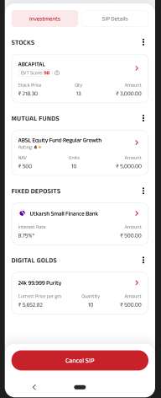 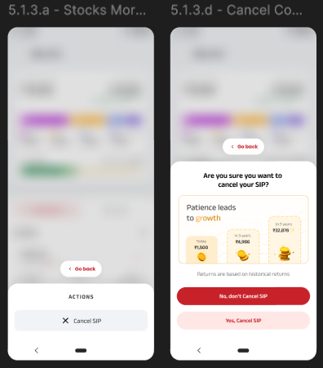

**SIP Details**

When user clicks on SIP Details page, following details will be displayed

1. Next SIP On Date with calendar icon – This indicated the next SIP execution date
2. Payment Streak header is displayed with a number at right indicating the total number of successful installments done still now against SIP
   1. Last 5 months (including current month) Payment Success/Failure details will be displayed. If all the SIP installments in a SIP basket (Stocks, MFs, FD and Digital Gold) are successfully executed it will be considered as success and if any of the installment in SIP basket is failed then it considered as Failed

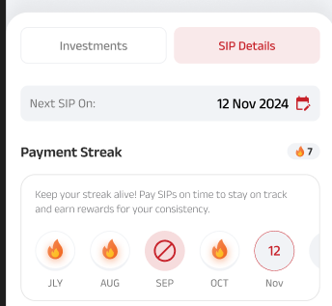

1. Below the payment streak, Transactions will be displayed. Last four transactions status will be displayed with View All option. The transactions card should contain following details
   1. A green tick or Red Exclamation to indicate success/failure
   2. Stock/Fund name with current installment number
   3. Amount
   4. Successful/Failure message
2. The transactions will be captured on individual level for example in a SIP basket if we have 2 stocks, 2 MFs, 1FD and 1 Digital Gold then it should have total of 6 installments for a month and each individual installment will be considered as a separate transaction

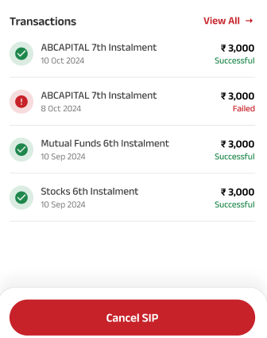

1. When user clicks on View All, a Transaction History screen will be opened with different tabs Stocks, Mutual Funds, Fixed Deposit, Digital Gold and help button at top right corner
2. By default, Stocks tab will be displayed, and installment details will be listed on card format against each stock level available in the Stock basket
3. By clicking on Mutual Funds tab, installment details will be displayed on card format against each fund available in the MF basket
4. If the transaction status of Stock or MF is in progress, then “In progress” text should be displayed under Amount and a text “It might take 2-3 days to reflect in your portfolio”

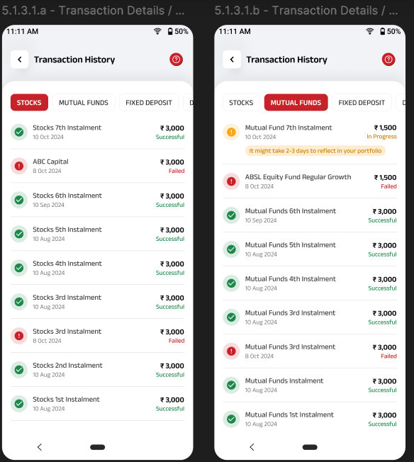

1. If Fixed Deposit tab is clicked, fixed deposit installments list should be displayed on individual FD available in the FD basket with failure/success status
2. If Digital Gold tab is clicked, Digital gold installments list should be displayed with failure/success status
3. When user clicks on any one of the Stock transactions, user will navigate to respective Stock page (the same screen should appear when user clicks the individual stock displayed on investment tabs) and following details will be available
   1. Stocks SIP header with back button
   2. Help button at top right corner
   3. Selected stock details in card format with following details
      1. Stock Name
      2. QVT score with questionnaire
      3. Stock price
      4. Invested Amount
      5. Current value
      6. Return
   4. Monthly SIP Amount with edit button
   5. Payment streak section respective to selected individual stock
   6. Transactions section last four transactions related to selected stock with view all button
   7. Cancel SIP button – Clicking on cancel should cancel selected stock only

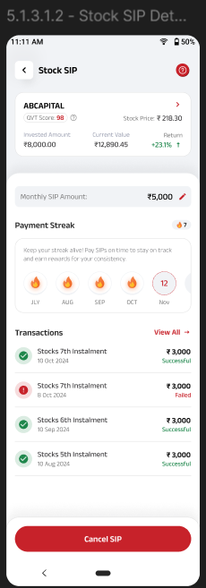

1. When user clicks on any one of the MF transactions, user will navigate to respective funds page (the same screen should appear when user clicks the individual MF displayed on investments tab) and following details will be available
   1. Mutual Fund SIP header with back button
   2. Help button at top right corner
   3. Selected Fund details in card format with following details
      1. Fund Name
      2. Rating
      3. NAV
      4. SIP Date
      5. Next Installment
      6. Start Date
      7. End Date
      8. Folio.No
   4. Monthly SIP Amount with edit button
   5. Payment streak section respective to selected individual fund
   6. Transactions section last four transactions related to selected fund with view all button
   7. Mandate Details related to MF
   8. Cancel SIP button – Clicking on cancel should cancel the selected fund only

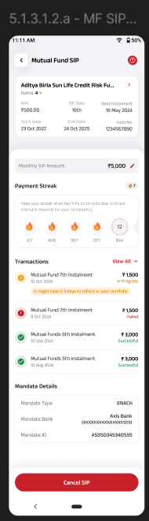

1. When user clicks on any one of the Digital Gold transactions, user will navigate to respective Digital Gold page (the same screen should appear when user clicks the individual Digital Gold displayed on investments tab) and following details will be available
   1. Digital Gold SIP header with back button
   2. Help button at top right corner
   3. Digital Gold detail card with following details
      1. 24k 99.999 Purity with arrow at the top right of the card
      2. Total Invesment
      3. Frequency
      4. Next Installment
      5. Investment via the SIP - 0.780 gms – Current accumlated gold gms should be displayed
   4. Monthly SIP Amount with edit button
   5. Payment streak section respective to selected Digital Gold
   6. Transactions section last four transactions related to selected fund with view all button
   7. Mandate Details related to Digital Gold
   8. Cancel SIP button – Clicking on cancel should cancel the selected Digital Gold SIP only

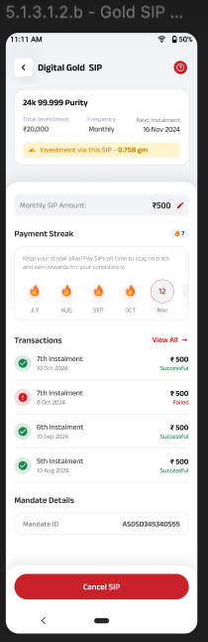

**Rowy:** Not applicable

**API**

1. Current value calculation in the investment details card
2. Questionnaire cards related to QVT
3. Stock details
4. Fund Details
5. Returns displayed on Stock SIP page

**Digio - Inprogress state during payment**

**Figma link:** [Portfolio Revamp](https://protect.checkpoint.com/v2/r05/___https://www.figma.com/design/mIbZMrzUAPOKeswB9mBilJ/UI-Design?node-id=1472-13646&node-type=canvas___.YXBzMTphZGl0eWFiaXJsYWNhcGl0YWw6YzpvOjA1ZmJjZmQwYWE0OTZhOTQwMWQyMWQzMTNhZTM0YTlmOjc6OWRlMDphZWE5NGQ4ZGFkODc0NzljMDNkYjc2MTk3ZjBiNWE5Y2E2NzE4NTBiYzZlN2Y0ODMxMzk3ZTE3ZDAxNWZkZjhmOnA6RjpO)

**Acceptance Criteria**

1. When user clicks on any SIP card displayed under My investments, would navigate to respective SIP page
2. When user clicks on back button on SIP page, would navigate to dashboard
3. When user clicks on investments tab, assets details should be displayed
4. When user clicks on SIP Details tab, SIP details info should be displayed
5. When user clicks on View all in transaction, transactions history page should be displayed
6. When user clicks on individual transactions respective stock/mf/fd/digital gold information should be displayed
7. When user does Cancel SIP from investment tab, complete SIP should get cancelled
8. When user does Cancel SIP from individual asset page, selected asset should get cancelled

**Queries**

1. Is calculate returns needed in dashboard (5.1)
2. Figma screens for help section (Question mark symbol in dashboard) (5.1.3.1.a), FAQ (5.1.3.1)
3. E-madate details are missing in individual Stock SIP detail is it needed or not? (5.1.3.1.2)
4. Can we remove arrow mark displayed in SIP details section in individual sip detail (5.1.3.1.2)
5. In Figma 5.1.3.d - Cancel information screen, we are displaying bar charts with returns, where we are displaying Today, In 3 years and In 5 years. But for stock we only have 3,6 and 12 months returns in API
6. No transaction screen for FD

**User Story ID**: 10

**Use Story Name**: Goal Transaction – Pre-SIP State

**Use Story Description**: User should be able to see the Investment, SIP details when the SIP is in Pre-SIP State

**Actors**: New/existing ABCD super app user.

**User Navigation**: ABCD Super App Landing Page → Invest → Simplinvest->Dashboard

**Functional Flow**

1. When user clicks on the SIP card displayed in dashboard, for which set up is completed and waiting for 1st installment to be executed user will be navigate to SIP details page
2. The SIP Details page will have following items in top section
   1. Goal name with back button at top left
   2. FAQ section at top right
   3. Invested Amount – Total amount invested till across multiple SIP baskets
   4. Current value – Current value of invested will be zero
   5. Bifurcation of assets invested is displayed as bar chart with name of the asset, percentage and amount
   6. Progress bar showing Saved amount and Goal amount, whereas saved amount will be zero

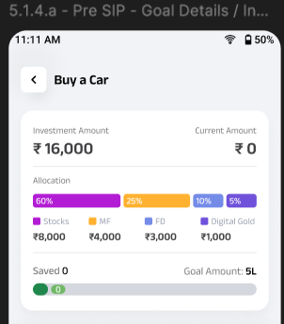

1. In the Investment tab, the assets details will be displayed (refer user story 9 for details)

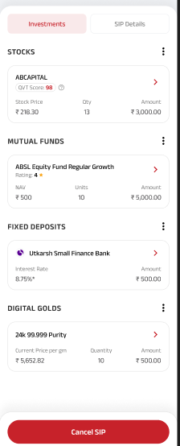

1. Clicking on SIP details will navigate to SIP details page, the SIP details page will have following contents
   1. Upcoming SIP on Date with calendar icon
   2. Upcoming transactions with view all button
   3. The upcoming transaction will be displayed in card format with following details
      1. Stock/Fund name with text 1st installment
      2. Amount
      3. Date of first execution
      4. In progress text below the amount
      5. A text “It might take 2-3 days to reflect in your portfolio”
2. Cancel SIP button – Clicking on Cancel SIP, should cancel the complete SIP basket

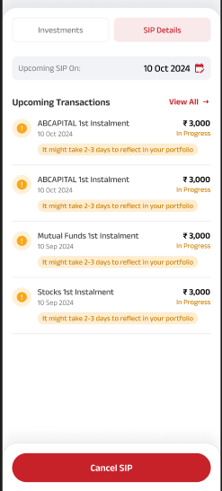

**API:**

1. Stock/Fund details
2. QVT score

**Figma link:** [Portfolio Revamp](https://protect.checkpoint.com/v2/r05/___https://www.figma.com/design/mIbZMrzUAPOKeswB9mBilJ/UI-Design?node-id=1472-13646&node-type=canvas___.YXBzMTphZGl0eWFiaXJsYWNhcGl0YWw6YzpvOjA1ZmJjZmQwYWE0OTZhOTQwMWQyMWQzMTNhZTM0YTlmOjc6OWRlMDphZWE5NGQ4ZGFkODc0NzljMDNkYjc2MTk3ZjBiNWE5Y2E2NzE4NTBiYzZlN2Y0ODMxMzk3ZTE3ZDAxNWZkZjhmOnA6RjpO)

**Acceptance Criteria:**

1. When user clicks on SIP card displayed in dashboard should navigate to SIP details page
2. When user clicks on SIP Details tab, SIP info screen should be displayed

**User Story ID**: 11

**Use Story Name**: Drafts section displayed on dashboard

**Use Story Description**: User should be able to navigate to drafts screen and resume the journey

**Actors**: New/existing ABCD super app user.

**User Navigation**: ABCD Super App Landing Page → Invest → Simplinvest->Dashboard->Drafts

**Functional Flow**

When user clicks on drafts button at dashboard, user should navigate to drafts screen and following details should be displayed

1. A back button with header Drafts
2. SIP details which is in set up incompletion state in card format
3. The SIP details cards will be displayed based on the current progress of SIP set up with Goal Name, SIP Amount, KYC, Mandate status with link to complete the KYC, Mandate and account setup
4. By clicking on the SIP card will land on respective section where SIP is currently in progress

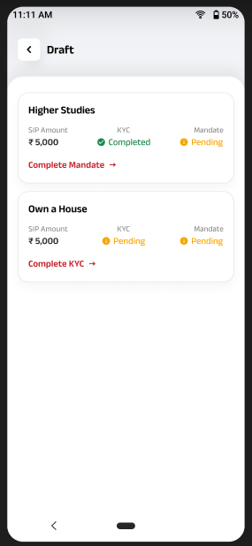

**FireStore**

1. The journey detail should come from firestore

**Figma link:** [Portfolio Revamp](https://protect.checkpoint.com/v2/r05/___https://www.figma.com/design/mIbZMrzUAPOKeswB9mBilJ/UI-Design?node-id=1472-13646&node-type=canvas___.YXBzMTphZGl0eWFiaXJsYWNhcGl0YWw6YzpvOjA1ZmJjZmQwYWE0OTZhOTQwMWQyMWQzMTNhZTM0YTlmOjc6OWRlMDphZWE5NGQ4ZGFkODc0NzljMDNkYjc2MTk3ZjBiNWE5Y2E2NzE4NTBiYzZlN2Y0ODMxMzk3ZTE3ZDAxNWZkZjhmOnA6RjpO)

**Acceptance Criteria**

1. When user clicks on drafts, drafts screen should be displayed
2. When user clicks on any SIP, user should land on respective section where it was pending

**User Story ID**: 11

**Use Story Name**: Calculator

**Use Story Description**: User should be able to access calculators

**Actors**: New/existing ABCD super app user.

**User Navigation**: ABCD Super App Landing Page → Invest → Simplinvest->Dashboard

**Functional Flow**

When user clicks on calculator, calculator screen should be displayed with options

1. Profile Calculator
2. Goal Calculator

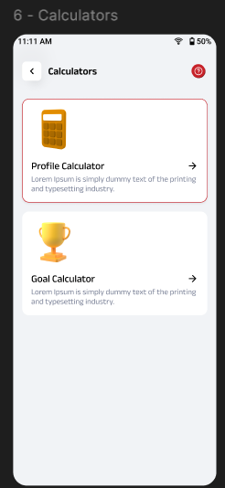

**Profile Calculator**

When user selects on Profile calculator, user should navigate to new screen and following questions should be displayed

1. What is your age with option to select the years with increment/decrement option
2. When user selects the age and clicks on Continue next, user should navigate to next page
3. The question should be ‘Identify as’ with options Male, Female and I prefer not to disclose and when user selects any one of the options and clicks on continue
4. User will land on next page with question “Total SIP Amount” with horizontal bar to select the amount and increment/decrement options to select the total number of months/years to be invested
5. When user selects the amount and years/months and clicks on continue button next page with question “How much risk would you like to take” will be displayed with options Low risk, Medium risk and High risk
6. After selecting the risk type and click on calculate, user will navigate to next page
7. Calculators page will be displayed with amount user can accumulate and assets to be invested and Recalculate button

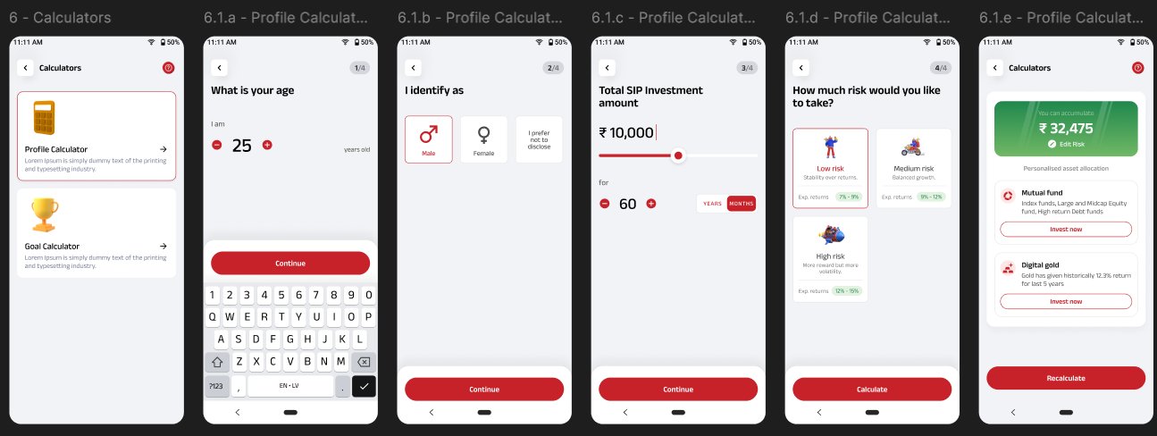

**Goal Calculator**

When user selects on Goal calculator, user should navigate to new screen and following questions should be displayed

1. Back button at left with text Setup your goal
2. Text – What's your financial goal?
3. A text field to type the goal name with inline text “Your Goal Name” or
4. An option to select the existing goal name with icon
   1. Buy a car
   2. Own a House
   3. Marriage
   4. Vacation
   5. Kids Future
   6. Savings
5. After selecting the Goal name and user clicks on continue, user will navigate to next screen
6. User will land on next page with question “Total SIP Amount” with horizontal bar to select the amount and increment/decrement options to select the total number of months/years to be invested
7. When user selects the amount and years/months and clicks on continue button next page with question “How much risk would you like to take” will be displayed with options Low risk, Medium risk and High risk
8. After selecting the risk type and click on calculate, user will navigate to next page
9. Calculators page will be displayed with amount user can accumulate and assets to be invested and Recalculate button

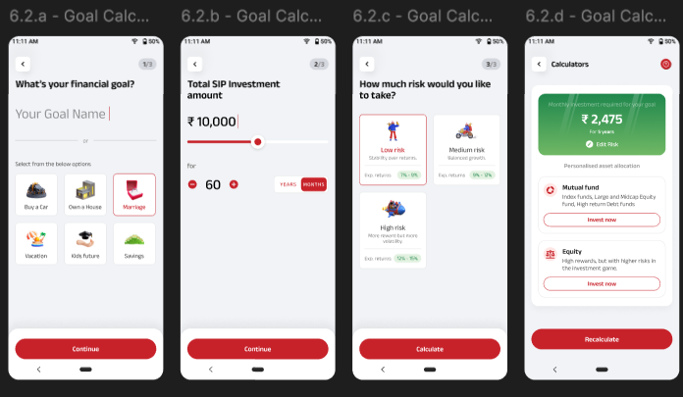

**Figma link:** [Portfolio Revamp](https://protect.checkpoint.com/v2/r05/___https://www.figma.com/design/mIbZMrzUAPOKeswB9mBilJ/UI-Design?node-id=1472-13646&node-type=canvas___.YXBzMTphZGl0eWFiaXJsYWNhcGl0YWw6YzpvOjA1ZmJjZmQwYWE0OTZhOTQwMWQyMWQzMTNhZTM0YTlmOjc6OWRlMDphZWE5NGQ4ZGFkODc0NzljMDNkYjc2MTk3ZjBiNWE5Y2E2NzE4NTBiYzZlN2Y0ODMxMzk3ZTE3ZDAxNWZkZjhmOnA6RjpO)

**Acceptance Criteria**

1. When user clicks on calculator, user should land calculator screen
2. When user clicks on profile/goal calculator respective screens should be displayed
3. When user clicks on recalculate the steps should start from the first

**User Story ID**: 12

**Use Story Name**: How to do SIP

**Use Story Description**: User should be able to navigate to coach marks when How to do SIP accessed from dashboard

**Actors**: New/existing ABCD super app user.

**User Navigation**: ABCD Super App Landing Page → Invest → Simplinvest->Dashboard

**Functional Flow**

When user clicks on How to do SIP, user should navigate to splash screens with option to Skip and click on Next

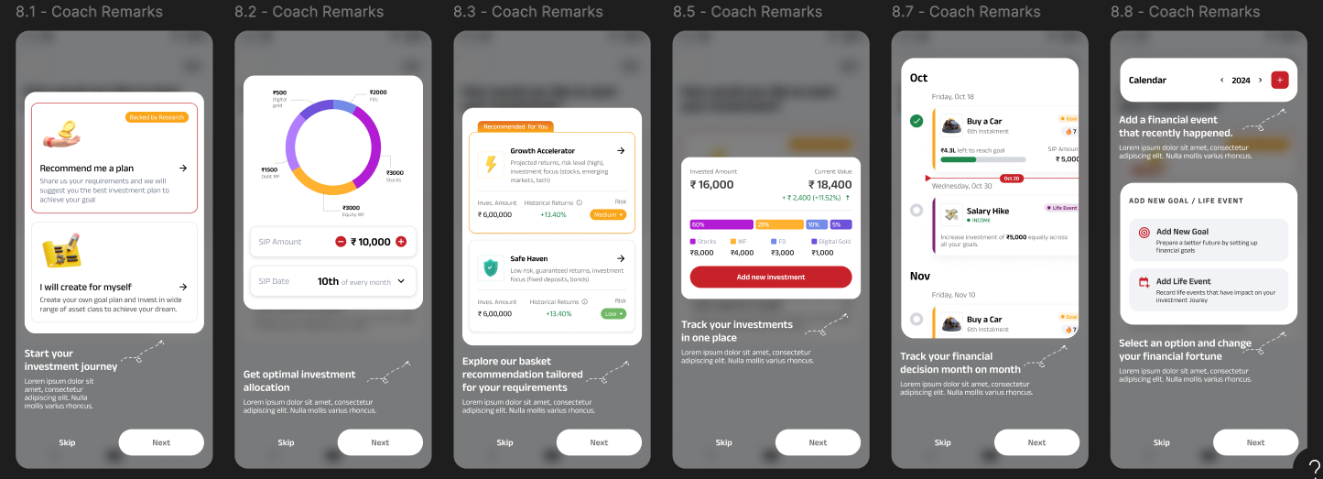

**Rowy:**

1. The splash screens should come from Rowy and same should get configured

**Figma link:** [Portfolio Revamp](https://protect.checkpoint.com/v2/r05/___https://www.figma.com/design/mIbZMrzUAPOKeswB9mBilJ/UI-Design?node-id=1472-13646&node-type=canvas___.YXBzMTphZGl0eWFiaXJsYWNhcGl0YWw6YzpvOjA1ZmJjZmQwYWE0OTZhOTQwMWQyMWQzMTNhZTM0YTlmOjc6OWRlMDphZWE5NGQ4ZGFkODc0NzljMDNkYjc2MTk3ZjBiNWE5Y2E2NzE4NTBiYzZlN2Y0ODMxMzk3ZTE3ZDAxNWZkZjhmOnA6RjpO)

**Acceptance Criteria:**

1. When user clicks on How to do SIP, user should navigate to splash screens
2. When user clicks on skip option the splash screens should get dismissed
3. When user clicks on Next button, next splash screen will be displayed

**KYC Updated**

**User Story ID**: 7

**Use Story Name**: KYC and Payment

**Use Story Description**: User should be able to complete the order summary after adding the assets

**Actors**: New/existing ABCD super app user.

**User Navigation**: ABCD Super App Landing Page → Invest → Simplinvest->Set up Goal-> Complete Recommendation->Order Summary

**Functional Flow**

Once the addition of assets is completed and user clicks on ‘Start Investing’ button displayed at the bottom of recommendation screen, user will navigate to order summary page. The order summary page should have following contents

* A back button at top left corner with text Order Summary and Goal name
* A Question icon at the right top corner, by clicking on the same should take the user to help section
* A progress section with header Set Up SIP in 15 mins and a text ‘Documents Required’
* The progress bar will be dynamically updated once user completed KYC, E-mandate and Bank Account set up
* The progress bar logic should give weightage to 25% each for Stocks, Funds, FD and Digigold
* Stocks, Funds, FD and Digigold has 2 setups (KYC and E-mandate) so the weightage will be 12.5 for each action but on completion it should be rounded off whole number
* FD will have only one action, so on completion of same it will be considered as 25%
* By clicking on Documents required, a pop up will be opened with separate tabs for Stock, MF, Digital Gold and FD. By default, Stock will be selected and following documents will be required
  + PAN Card with brief description
  + Aadhar card with brief description
  + Live Photo with brief description
* Below the Set up SIP card, Stocks card should be displayed
  + 5 mins Setup tag should be displayed at left top of the card
  + Stocks with Amount of assets selected
  + Create Demat account link – By clicking on the link should follow the process of creating a Demat account like in the existing flow
* Below the Stocks card, Mutual fund card should be displayed
  + 5 mins Setup tag should be displayed at left top of the card
  + Mutual fund with Amount of assets selected
  + A link to ‘Complete Your KYC’ will be displayed – By clicking on the link should follow the process of completing the KYC like existing flow
* Below the Mutual fund card, Digital Gold card should be displayed
  + 5 mins Setup tag should be displayed at left top of the card
  + Digital Gold text with invested amount should be displayed
  + A link to Complete the 'Setup Account' will be displayed – By clicking on the link should follow the process of completing the KYC like existing flow
* Below the Digital Gold card, Deposit card should be displayed
  + 5 mins Setup tag should be displayed at left top of the card
  + Deposit text with invested amount should be displayed
  + A link to Complete the 'Setup Account' will be displayed – By clicking on the link should follow the process of completing the KYC like existing flow
* At bottom total SIP basket amount/month will be displayed with link view plan details, proceed button will be in disabled state and Save button to save the progress
* If user clicks on Save/kills the app then the status should get saved and user should be able to access from dashboard/drafts screen
* Once the KYC/Setup is completed for Stocks/Mutual Fund/Digital Gold, ‘5 mins Setup’ card header will change into KYC completed and ask for Setup E-mandate to respective cards
* For FD, once the Set-up account is completed, the header will change into Setup is completed
* When user clicks on E-mandate, will navigate to a pop up requesting for bank account details
  + Account type – By default it will be prefilled as ‘Savings’ and user will not allow to edit
  + Account number – User should be able to edit/enter the number
  + Bank Name – User should be able to input the bank name
  + Customer Name – User will be able to input the customer's name
  + Mobile no - User will be able to enter the customer phone number
  + Mandate amount – Total amount allocated in SIP basket and will be prefilled and in locked state
  + Mandate expiry – Mandate expiry date and will be in locked state
  + Create Mandate button at bottom, by clicking on the same E-mandate set up success message should be displayed
* Once mandate is completed, Success message screen should be displayed with SIP amount, SIP date on every month, bifurcation of assets in bar chart, added stock, MF, FD and Gold details in card format
* Back to dashboard button at bottom

Firestore:

1. Saved status of KYC, Mandate should get saved in firestore

Digio – KYC, E-mandate, payments and document upload part will be handled by digio

**Figma link:** [Portfolio Revamp](https://protect.checkpoint.com/v2/r05/___https://www.figma.com/design/mIbZMrzUAPOKeswB9mBilJ/UI-Design?node-id=1472-13646&node-type=canvas___.YXBzMTphZGl0eWFiaXJsYWNhcGl0YWw6YzpvOjA1ZmJjZmQwYWE0OTZhOTQwMWQyMWQzMTNhZTM0YTlmOjc6OWRlMDphZWE5NGQ4ZGFkODc0NzljMDNkYjc2MTk3ZjBiNWE5Y2E2NzE4NTBiYzZlN2Y0ODMxMzk3ZTE3ZDAxNWZkZjhmOnA6RjpO)